**Constructor and destructor:**

1. Write a c++ program to create a class for a bank account with a constructor and a destructor

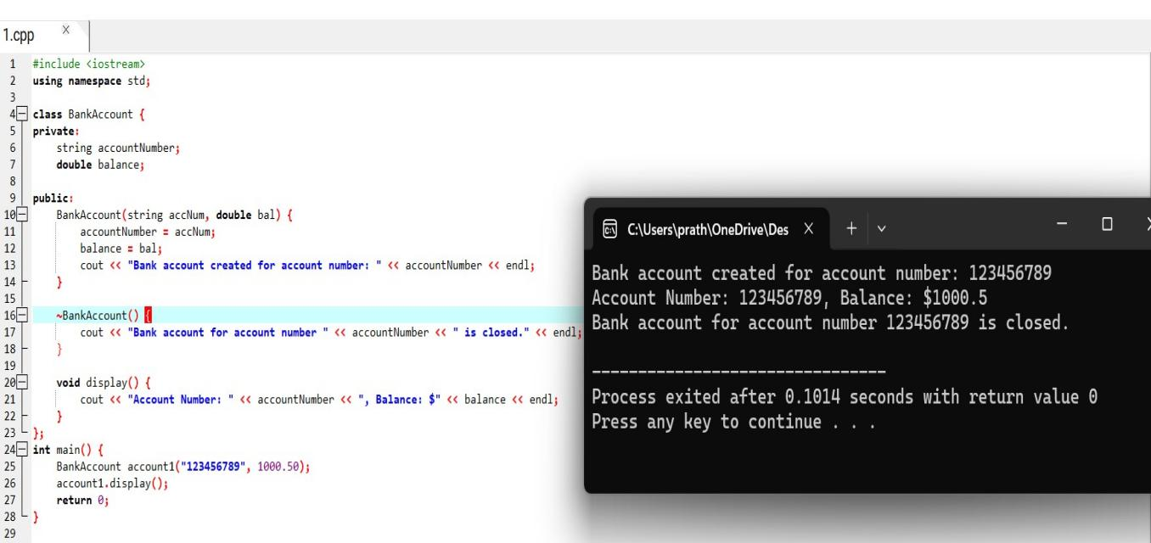

1. Write a c++ program to create a class for a car with a constructor and a destructor

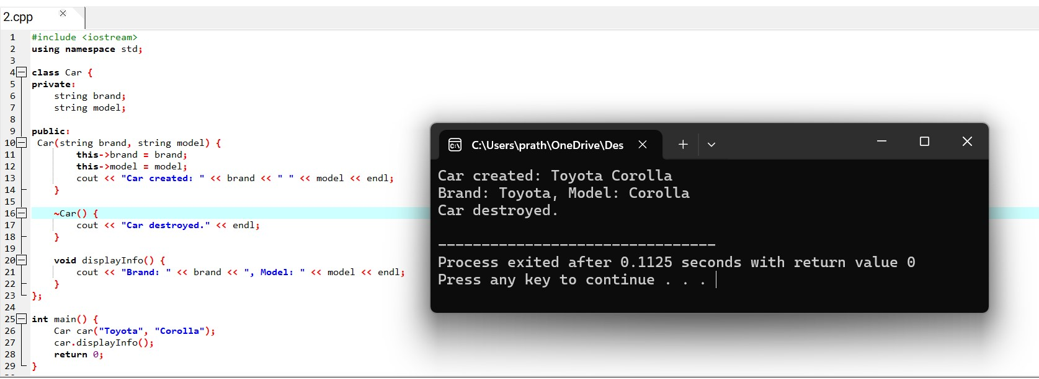

1. Write a c++ program to create a class for a rectangle with a constructor and a destructor

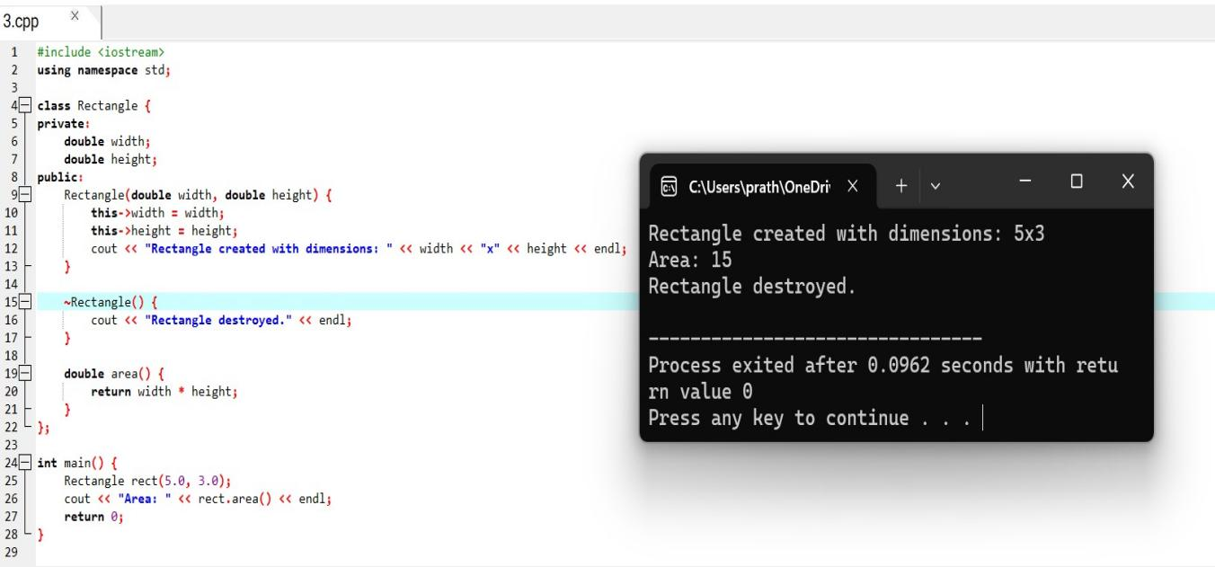

1. Write a c++ program to create a class for a book with a constructor and a destructor

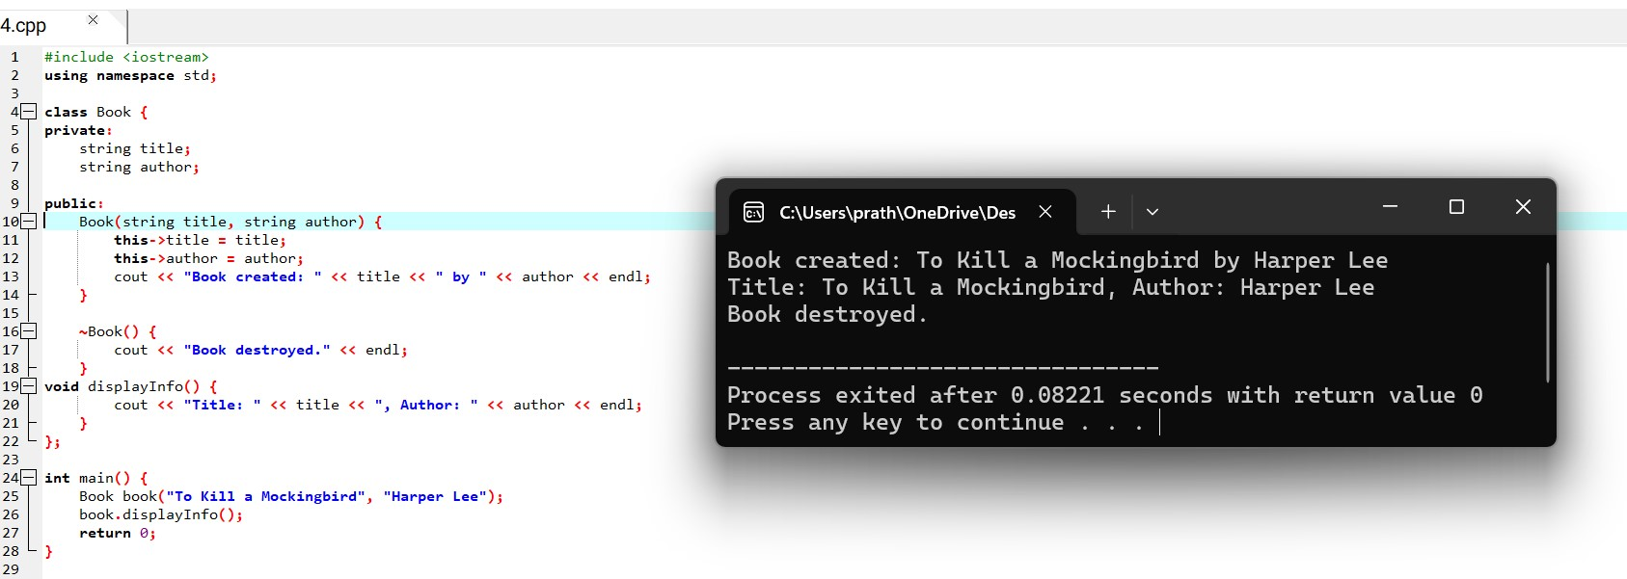

1. Write a c++ program to create a class for student with a constructor and a destructor

